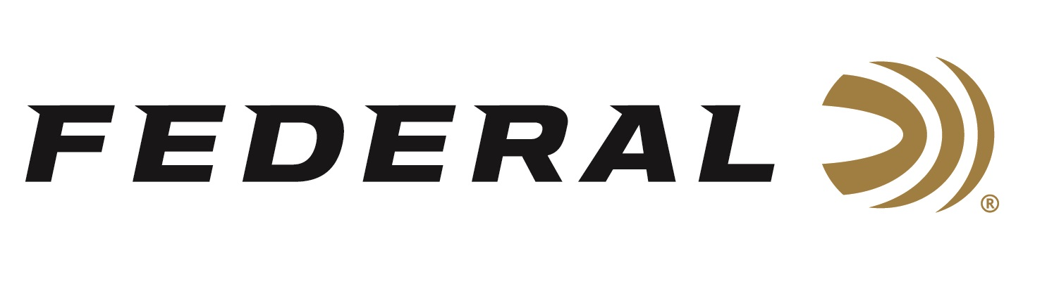

FOR IMMEDIATE RELEASE

Federal Ammunition’s Support of Injured Veterans Approaches $250,000

ANOKA, Minnesota – February 3, 2021 – Federal Ammunition is committed to empowering our nation’s injured veterans. Since 2011, Federal Ammunition has supported Wounded Warrior Project (WWP) and the nonprofit’s free programs and services with an annual contribution to the Minnesota Wounded Warrior Charity Golf event. To date, the total contribution is just shy of $248,000 dollars.

Wounded veterans face significant challenges when they return to civilian life, and through the generous support of donors and corporate partners, WWP provides support during their recoveries, wherever they are in that journey.

“I’m proud of this program,” said Rick Stoeckel, Federal Ammunition’s Shotshell Product Director. “When our wounded heroes return, the needs are great and Federal is proud to assist in any way that we can, and the consumers have responded by purchasing the product that supports Wounded Warrior Project in our backyard of Minnesota and throughout the United States.”

Through our financial contribution, Federal Ammunition is directly supporting the programs and services that give warriors access to independence, mental and physical health, career counseling, peer support and connections to other veterans, and family support—free of charge.

Even the most challenging targets are no match for consistent, hard-hitting Federal Top Gun target loads. High-quality lead shot produces even patterns that crush clays. These loads also feature consistent, reliable Federal primer; an eight-segment crimp; and an unique wad column for consistent patterns.

Federal ammunition can be found at dealers nationwide or purchased online direct from Federal. For more information on all products from Federal or to shop online, visit www.federalpremium.com.

Press Release Contact: JJ Reich
Senior Manager – Press Relations
E-mail: VistaPressroom@VistaOutdoor.com
About Federal Ammunition
Federal, headquartered in Anoka, MN, is a brand of Vista Outdoor Inc., an outdoor sports and recreation company. From humble beginnings nestled among the lakes and woods of Minnesota, Federal Ammunition has evolved into one of the world's largest producers of sporting ammunition. Beginning in 1922, founding president, Charles L. Horn, paved the way for our success. Today, Federal carries on Horn's vision for quality products and service with the next generation of outdoorsmen and women. We maintain our position as experts in the science of ammunition production. Every day we manufacture products to enhance our customers' shooting experience while partnering with the conservation organizations that protect and support our outdoor heritage. We offer thousands of options in our Federal Premium and Federal® lines-it's what makes us the most complete ammunition company in the business and provides our customers with a choice no matter their pursuit.

